Dijkstra Algorithm Sözde Kod ve Karmaşıklığı
Günlük hayatta sıkça kullandığımız navigasyon uygulamalarının temelinde olan Dijsktra algoritması bir en kısa yolu bulma algoritmasıdır.
Orijinal olarak kaynak noktadan hedef noktaya gidilecek en kısa yolu bulmak üzere tasarlanmış olsa da, günümüzde kaynak noktadan tüm noktalara gidilecek en kısa yolu bulan versiyonu tercih ediliyor. Bu algoritma Greedy Approach uygular (Açgözlü Yaklaşım), dolayısıyla her adımda en kısa yolu tercih ederek devam eder.
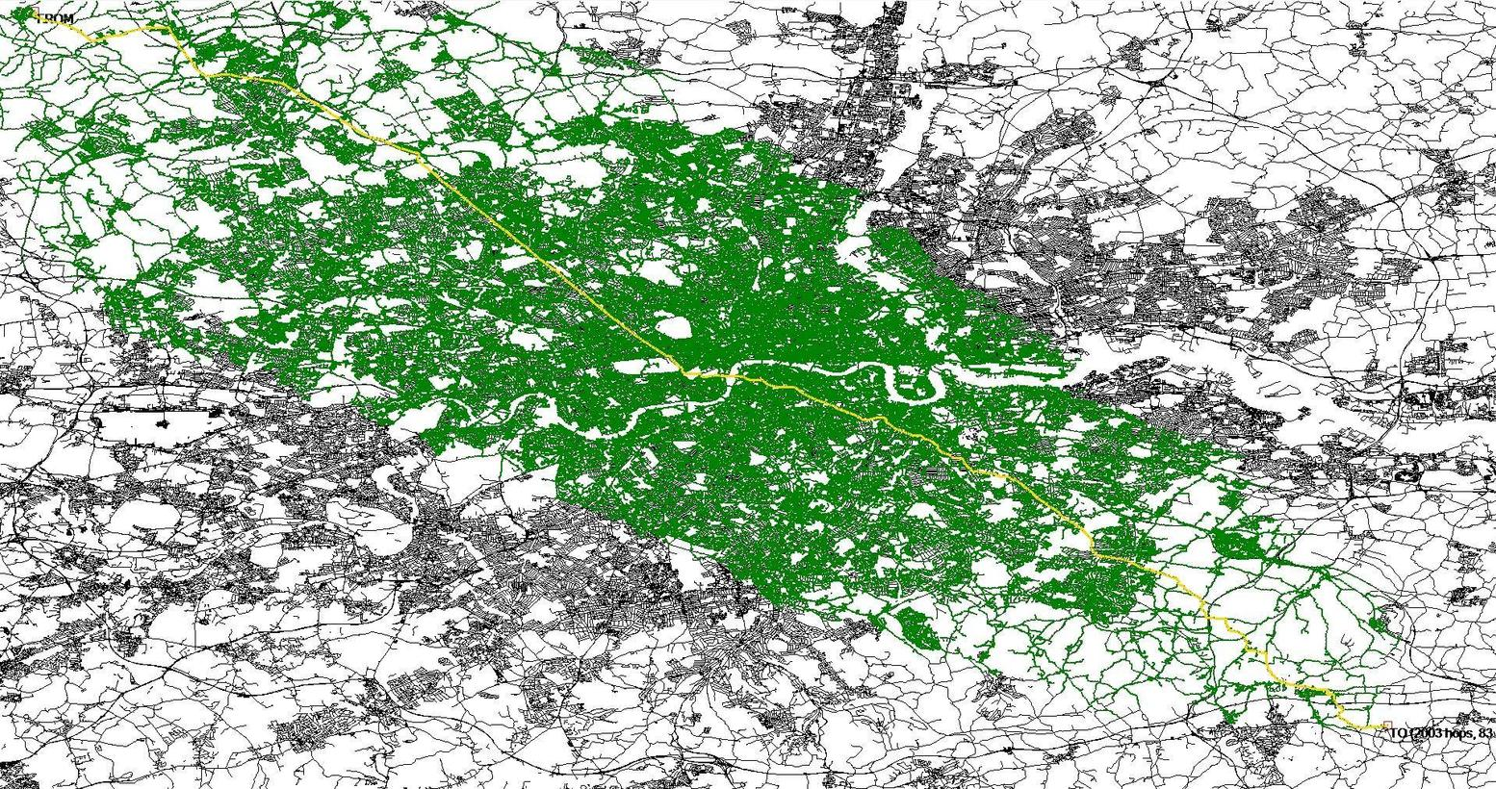
Dijkstra algoritmasını sadece weighted (ağırlıklı) ve pozitif değerlere sahip graph`larda uygulayabiliriz. Graph directed (yönlü) ve ya undirected (yönsüz) olabilir ama içindeki değerlerin mutlaka pozitif olması gerek, negatif değer kullanılırsa algoritma başarılı sonuç veremez.
Sözde kodu: 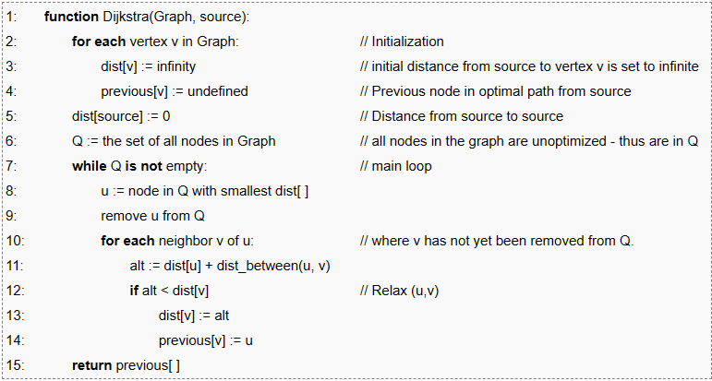
Zaman karmaşıklığı: matris kullanıldığına (orijinal hali) O(V^2)’yken “min-priority queue” kulanıldığında O(V+ElogV)’e düşüyor. V nokta sayısını (vertex), E yol sayısını (edge) temsil ediyor.
Dijkstra örnek:
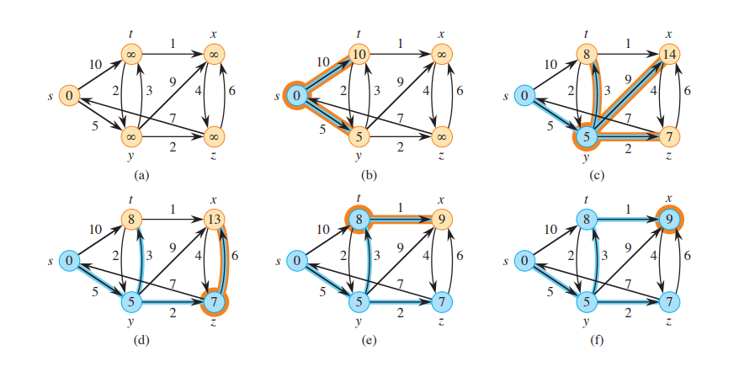
Previous node’lar da her değer güncellenmesi olduğunda güncellenir.

BELLMAN-FORD ALGORITHM sözde kod ve karmaşıklığı

Bellman-Ford is a single source shortest path algorithm that determines the shortest path between a given source vertex and every other vertex in a graph. Imagine you have a map with different cities connected by roads, each road having a certain distance. The Bellman-Ford Algorithm is like a guide that helps you find the shortest path from one city to all other cities, even if some roads have negative lengths. It’s like a GPS for computers, useful for figuring out the quickest way to get from one point to another in a network. The shortest path cannot be found if there exists a negative cycle in the graph. If we continue to go around the negative cycle an infinite number of times, then the cost of the path will continue to decrease (even though the length of the path is increasing). As a result, Bellman-Ford is also capable of detecting negative cycles which is an important feature.
Pseudocode:
Procedure shortest paths (G, l, s)
Input: Directed graph G = (V, E); Edge lengths {l_{e}: e ∈ E} with no negative cycles; vertex s ∈ V
Output: For all vertices u reachable from s, dist (u) is set to the distance from s to u.
for all u ∈ V ;
dist (u) =∞
prev(u) = nil
dist (s) = 0
repeat |V|-1 times ;
for all e ∈ E ;
update (e)
procedure update ((u, v) ∈ E)dist (v) = min
{dist (v), dist (u) + l (u, v)}
TIME COMPLEXITY: O(|V||E|)=O(n.n)=O($n^{2}$)
Bellman Ford Örnek:

S
B
E
D
C
A
10
8
1
-1
1
-2
-4
2
 | S | A | B | C | D | E
START | 0 | 10 | ∞ | ∞ | ∞ | 8
FROM A | 0 | 10 | ∞ | 12 | ∞ | 8
FROM B
FROM C | 0 | 10 | 10 | 12 | ∞ | 8
FROM D
FROM E | 0 | 10 | 10 | 12 | 9 | 8
FROM A | 0 | 10 | 10 | 12 | 9 | 8
FROM B | 0 | 10 | 10 | 12 | 9 | 8
FROM C | 0 | 10 | 10 | 12 | 9 | 8
FROM D | 0 | 5 | 10 | 8 | 9 | 8
FROM E | 0 | 5 | 10 | 8 | 9 | 8
FROM A | 0 | 5 | 10 | 7 | 9 | 8
FROM B | 0 | 5 | 10 | 7 | 9 | 8
FROM C | 0 | 5 | 5 | 7 | 9 | 8
FROM D | 0 | 5 | 5 | 7 | 9 | 8
FROM E | 0 | 5 | 5 | 7 | 9 | 8
FROM A | 0 | 5 | 5 | 7 | 9 | 8
FROM B | 0 | 5 | 5 | 7 | 9 | 8
FROM C | 0 | 5 | 5 | 7 | 9 | 8
FROM D | 0 | 5 | 5 | 7 | 9 | 8
FROM E | 0 | 5 | 5 | 7 | 9 | 8
FROM A | 0 | 5 | 5 | 7 | 9 | 8
FROM B | 0 | 5 | 5 | 7 | 9 | 8
FROM C | 0 | 5 | 5 | 7 | 9 | 8
FROM D | 0 | 5 | 5 | 7 | 9 | 8
FROM E | 0 | 5 | 5 | 7 | 9 | 8
Prim Algoritmasi sözde kod ve karmaşıklığı
Prim’s Algorithm for Minimum Spanning Tree (MST)

What is the Prim's Algorithm
Along with the algorithm, we will also see the working, example, pseudocode, complexity and applications of prim's algorithm. Before starting the main topic, we should discuss the basic and important terms such as spanning tree and minimum spanning tree.
- Spanning tree - A spanning tree is the subgraph of an undirected connected graph.
- Minimum Spanning tree - Minimum spanning tree can be defined as the spanning tree in which the sum of the weights of the edge is minimum. The weight of the spanning tree is the sum of the weights given to the edges of the spanning tree.
- Prim's Algorithm is a greedy algorithm that is used to find the minimum spanning tree from a graph. Prim's algorithm finds the subset of edges that includes every vertex of the graph such that the sum of the weights of the edges can be minimized. Prim's algorithm starts with the single node and explores all the adjacent nodes with all the connecting edges at every step.
Before we look at how the Prim’s algorithm works, we should discuss what the greedy algorithm is.
What is the Greedy Algorithm
In computer science, a greedy algorithm is an algorithm that finds a solution to problems in the shortest time possible. It picks the path that seems optimal at the moment without regard for the overall optimization of the solution that would be formed.
Edsger Dijkstra, a computer scientist and mathematician who wanted to calculate a minimum spanning tree, introduced the term "Greedy algorithm". Prim and Kruskal came up with optimization techniques for minimizing cost of graphs.
Many Greedy algorithms were developed to solve graph problems. A graph is a structure made up of edges and vertices.
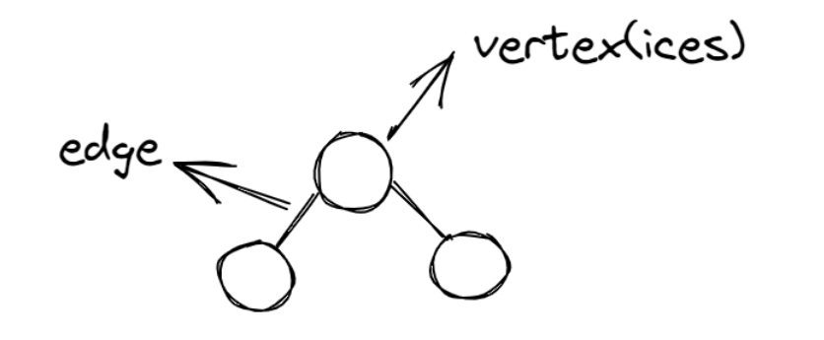
Diagram of a simple graph

Example: A graph has various weights and you are to determine the maximum value in the tree. You'd start by searching each node and checking its weight to see if it is the largest value.
There are two approaches to solving this problem: greedy approach or not greedy.
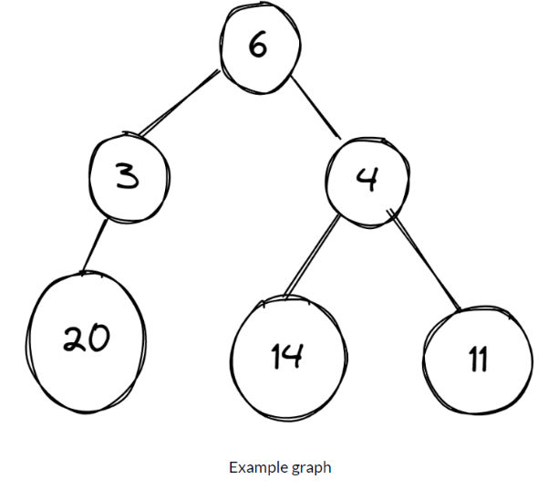

Greedy Approach :

In the images below, a graph has different numbers in its vertices and the algorithm is meant to select the vertex with the largest number.
Starting from vertex 6, then it's faced with two decisions – which is bigger, 3 or 4? The algorithm picks 4, and then is faced with another decision – which is bigger, 14 or 11. It selects 14, and the algorithm ends.
On the other hand, there is a vertex labeled 20, but this vertex has been added to 3, which the greedy does not consider to be the best choice because it chooses 14, which is the largest number in the graph.
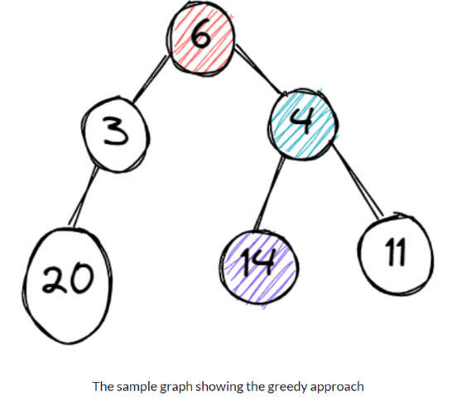

Not Greedy Approach :

The “not greedy” approach checks all options before arriving at a final solution, unlike the "greedy approach" which stops once it gets its results.
Starting from vertex 6, then it's faced with two decisions – which is bigger, 3 or 4? The algorithm picks 4, and then is faced with another decision – which is bigger, 14 or 11. It selects 14 and keeps it aside.
Then it runs the process again, starting from vertex 6. It selects the vertex with 3 and checks it. 20 is attached to the vertex 3 and the process stops. Now it compares the two results – 20 and 14. 20 is bigger, so it selects the vertex (3) that carries the largest number and the process ends.
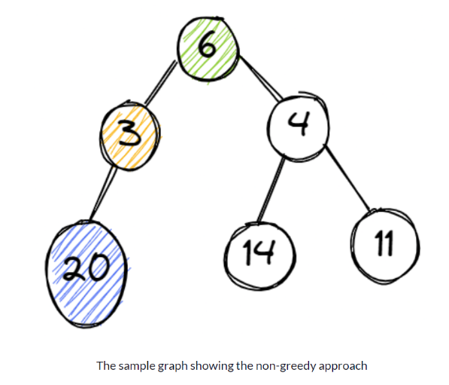

How to Use Greedy Algorithms
Before applying a greedy algorithm to a problem, you need to ask two questions:
- Do you need the best option at the moment for the problem?
- Do you need an optimal solution (either minimum or maximum value)?
If your answer to these questions is "Yes", then a greedy algorithm is a good choice to solve your problem.

How does the Prim's Algorithm work?
Prim's algorithm is a greedy algorithm that starts from one vertex and continues to add the edges with the smallest weight until the goal is reached. The steps to implement the prim's algorithm are given as follows -
- Step 1 - First, Initialize the minimum spanning tree with a vertex chosen at random.
- Step 2 - Find all the edges that connect the tree to new vertices, find the minimum edge and add it to the tree.
- Step 3 - Keep repeating step 2 until we get a minimum spanning tree.
Pseudocode of Prim's Algorithm

First, we create a null set A, where we will add all the edges of the minimum spanning tree. Then we create two sets of vertices U and V-U. V-U the list of vertices that haven’t been visited and U contains the list of vertices that have been visited. We move vertex by vertex, and move vertices from set V-U to set U by connecting the least weighted edge.

A = ∅;
U = {1};
while (U ≠ V)
let (u, v) be the least weighted edge such that
v ∈ V - U and u ∈ U;
A = A ∪ {(u, v)}
U = U ∪ {v}

Complexity of Prim's Algorithm

Data structure used for the minimum edge weights | Time Complexity
Adjacency matrix, linear searching |  | O(|V|²)
Adjacency list and binary heap |  | O(|E| log |V|)
Adjacency list and Fibonacci heap |  | O(|E|+ |V| log |V|)
Prim's algorithm can be simply implemented by using the adjacency matrix or adjacency list graph representation, and to add the edge with the minimum weight requires the linearly searching of an array of weights. It requires O(|V|²) running time. It can be improved further by using the implementation of heap to find the minimum weight edges in the inner loop of the algorithm.
The time complexity of the prim's algorithm is O(E logV) or O(V logV), where E is the number of edges, and V is the number of vertices.
Prim örnek
Example of Prim's Algorithm

Consider the following graph as an example for which we need to find the Minimum Spanning Tree (MST).

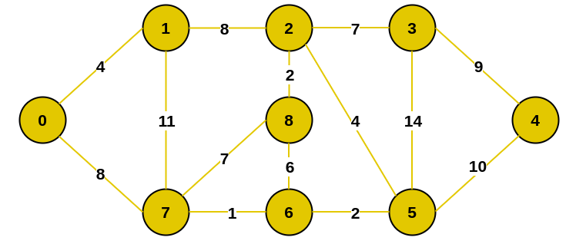

Solution:
Step 1 - Start by adding an arbitrary vertex to Vnew .
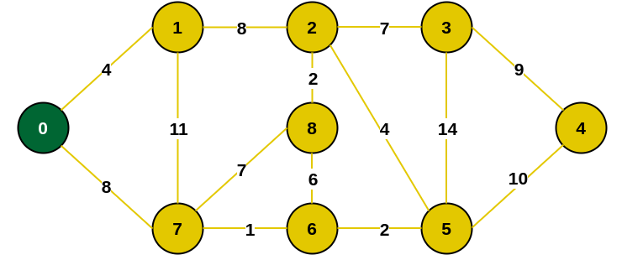

Step 1.1 - we have to find all the edges that connect the tree with the new vertices and mark the edges with blue paint.

8
4

8

Step 2 - From the edges found, select the minimum edge and mark the vertex with green paint to the tree.

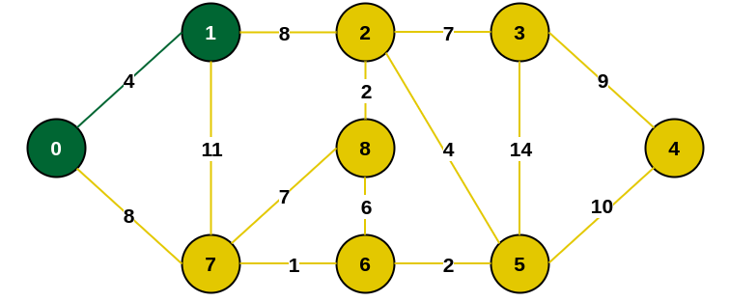

Step 2.1 - we have to find all the edges that connect the tree with the new vertices and mark the edges with blue paint.


8
11
8

Step 3 - From the edges found, select the minimum edge and mark the vertex with green paint to the tree. If two edges of the same size have the smallest value, it doesn't matter which edge we choose first.

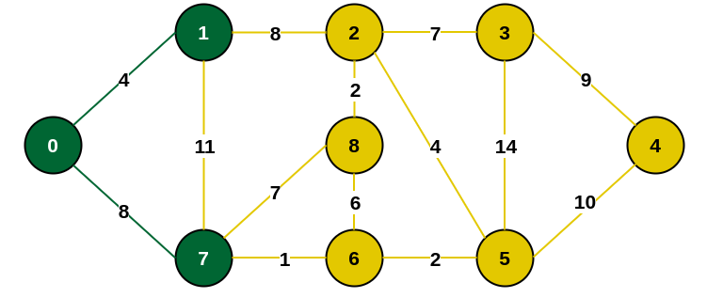

Step 3.1 - we have to find all the edges that connect the tree with the new vertices and mark the edges with blue paint.


1
7
8

Step 4 - From the edges found, select the minimum edge and mark the vertex with green paint to the tree.

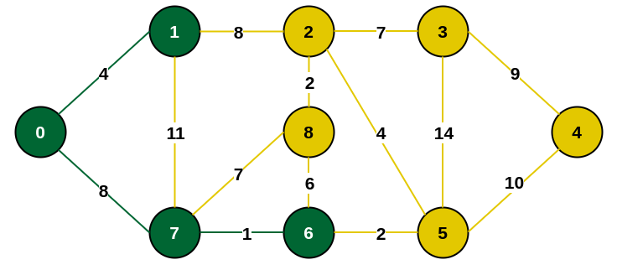

Step 4.1 - we have to find all the edges that connect the tree with the new vertices and mark the edges with blue paint.


2
6
7
8

Step 5 - From the edges found, select the minimum edge and mark the vertex with green paint to the tree.

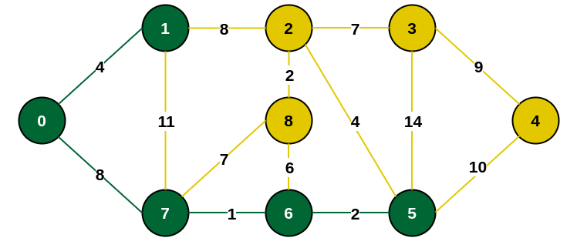

Step 5.1 - we have to find all the edges that connect the tree with the new vertices and mark the edges with blue paint.


10
14
4
6
7
8

Step 6 - From the edges found, select the minimum edge and mark the vertex with green paint to the tree.

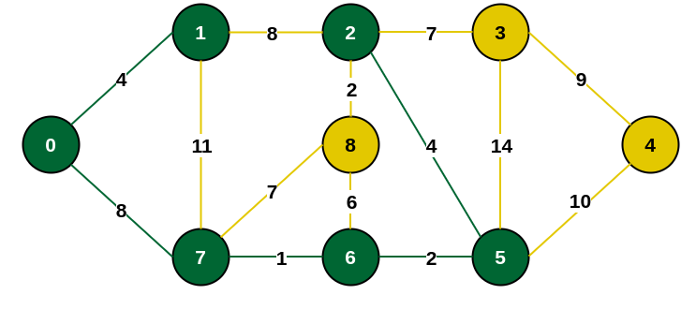

Step 6.1 - we have to find all the edges that connect the tree with the new vertices and mark the edges with blue paint.


14
6
7
10
7
2

Step 7 - From the edges found, select the minimum edge and mark the vertex with green paint to the tree.

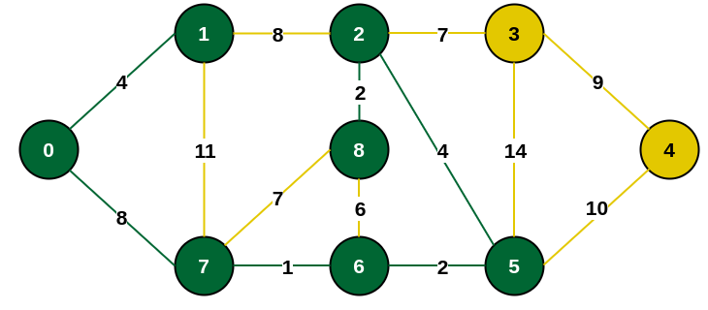

Step 7.1 - we have to find all the edges that connect the tree with the new vertices and mark the edges with blue paint.


10
14
7

Step 8 - From the edges found, select the minimum edge and mark the vertex with green paint to the tree.

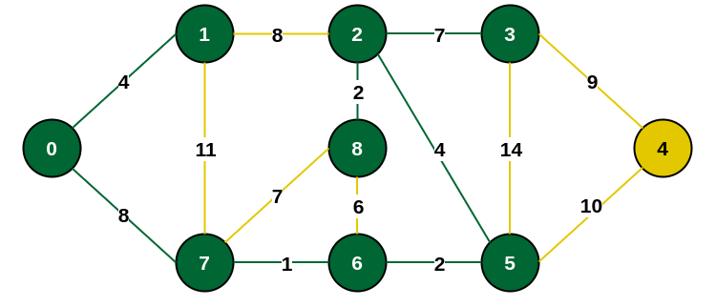

Step 8.1 - we have to find all the edges that connect the tree with the new vertices and mark the edges with blue paint.


10
9

Step 9 - From the edges found, select the minimum edge and mark the vertex with green paint to the tree.

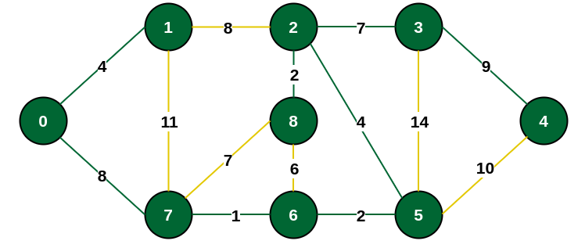

Final Step - Minimum Spanning Tree (MST)

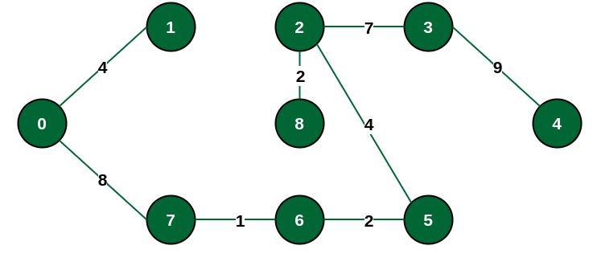
The final structure of the MST is as follows and the weight of the edges of the MST is
(4 + 8 + 1 + 2 + 4 + 2 + 7 + 9) = 37

Applications where Prim’s algorithm is generally used:
Prim’s Algorithm is used in various real-world applications where you need to find the Minimum Spanning Tree (MST) of a weighted graph. Here are some simple explanations of its uses:
Network Design: In telecommunications and computer networks, Prim’s Algorithm helps design efficient and cost-effective network layouts. It can be used to determine the optimal placement of communication cables or network connections while minimizing the total length or cost.
Circuit Board Design: When designing electronic circuit boards, you often want to minimize the length of connections between components to reduce interference and improve performance. Prim’s Algorithm can be employed to find the optimal arrangement of connections.
Transportation Planning: In transportation systems, such as road or railway networks, Prim’s Algorithm can help plan routes and connections. It ensures that you build new roads or railway tracks in a way that minimizes the total distance or cost.
Resource Management: When managing resources like pipelines for gas or water distribution, Prim’s Algorithm can determine the most efficient way to connect sources to destinations, minimizing the total length of pipelines while ensuring all areas are supplied.
Cluster Analysis: Prim’s Algorithm can be used in data analysis and clustering to find representative data points while minimizing the distance between them. This helps in identifying groups or clusters within datasets.
Image Processing: In image processing, it’s used for segmenting images into regions while minimizing the total “cut” cost. This can be applied in tasks like image segmentation and object recognition.
Robotics: In robotics, Prim’s Algorithm can be employed to plan paths for robots moving in a grid or on a map. It helps robots navigate efficiently while avoiding obstacles.
Spanning Tree Applications: Prim’s Algorithm, in general, is used in any application where you need to create a network or tree structure while minimizing some cost or distance measure. This could include tasks like designing electrical grids, connecting sensors in a sensor network, or creating a hierarchical structure in computer science.
Kruskal sözde kod ve karmaşıklığı


Kruskal Algoritması (Kruskal`s Minimum Spanning Tree Algorithm)
Kruskal Algoritması bağlı ağırlıklı grafik için minimum yayılan ağacı(minimum spanning tree)’yi bulmak için kullanılır. Algoritmanın asıl amacı, grafiğin her tepe noktasını geçebileceğimiz kenarların alt kümesini bulmaktır. Genel bir optimuma odaklanmak yerine her aşamada optimimum bir çözüm bulan açgözlü yaklaşımı takip eder.

Yayılan Ağaç(Spanning tree) Nedir?
Yayılan ağaç, grafiğin tüm köşelerini ve original grafiğin bazı kenarlarını içeren ve döngü olmamasını isteyen bir grafiğin alt kümesidir. Yayılan bir ağaç mutlaka benzersiz değildir - belirli bir grafik için birden fazla yayılan ağaç olması mümkündür. Bununla birlikte, belirli bir grafik her zaman en az bir yayılan ağaca sahip olacaktır. Yayılan ağaçtaki kenarlara "şube kenarları", yayılan ağaçta olmayan kenarlara "döngü kenarları" denir. Ve bu grafik türü, bir grafikteki tüm köşeleri bağlamak için gereken minimum kenar sayısını bulmaya yardımcı olur. Gereksiz yollara sahip minimal güvenli ağlar oluşturmak için de kullanılır.

Kruskal Algoritmasını Kullanarak Minimum Genişleme Ağacı Oluşturma
Minimum bir yayılan ağaç oluşturmak için önce Kruskal’ın Algoritmasında yer alan adımlara bakacaksınız:
- Adım 1: Tüm kenarları kenar ağırlıklarının sırasını artırarak sıralayın.
- Adım 2: En küçük kenarı seçin.
- Adım 3: Yeni kenarın yayılan ağaçta bir döngü veya döngü oluşturup oluşturmadığını kontrol edin.
- Adım 4: Döngüyü oluşturmazsa, o kenarı MST'ye ekleyin. Aksi takdirde atın.
- Adım 5: MST'de | V | - 1 kenar içerene kadar adım 2'den tekrarlayın.

- Kruskal Algoritmasının zayıflığı, eğer düğüm sayısı çok fazlaysa Dijkstra algoritmasından daha yavaş çalışacaktır, çünkü önce binlerce kenarı sıralamak sonra bir yol oluşturmak zorundadır.

- Kruskal Algoritmasının Zaman karmaşıklığı (Time Complexity)
Kruskal'ın algoritması, O(E logE) zaman alan kenarların sıralanmasını içerir; burada E, grafikteki kenarların sayısı ve V, köşelerin sayısıdır. Sıralama sonrasında tüm kenarlar yinelenir ve birleşim bulma algoritması uygulanır. birleşim bulma algoritması O(logV) zaman gerektirir. Yani genel olarak Kruskal algoritması O(E log V) zaman gerektirir.
1
Kruskal örnek

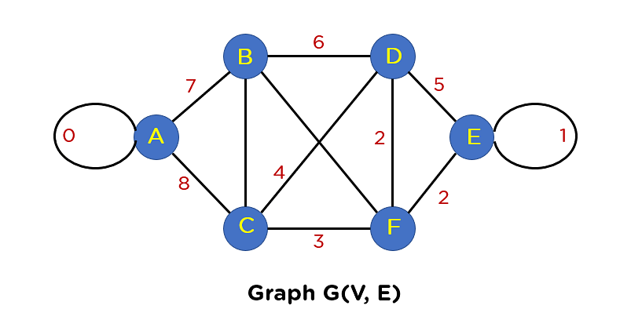
İlk adımımız, bütün kenarları ağırlıklarına göre sıralama olacak.
KenarlarAğırlık
E-F 2
F-D2
B-C3
C-F3
C-D4
B-F5
B-D6
A-B7
A-C8
Bu adımdan sonra, dahil edilen kenar ağaç yapınızda bir döngü oluşturmayacak şekilde MST'ye kenarlar ekleyeceksiniz. Seçeceğiniz ilk kenar, minimum kenar ağırlığı 2 olduğu için EF kenarıdır.
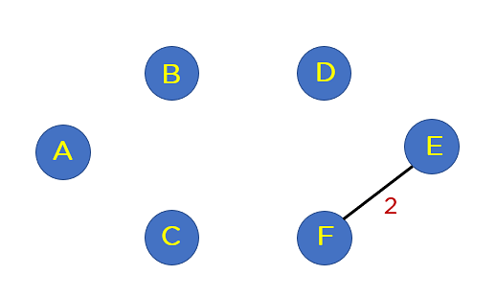
2
Yayılan ağaca kenar FD ekleyin.
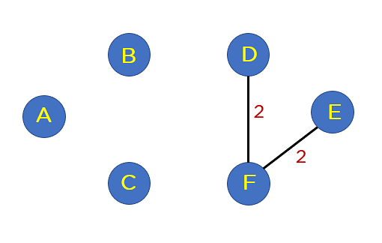
Herhangi bir döngü oluşturmadığı için yayılan ağaca BC kenarını ve CF kenarını ekleyin.
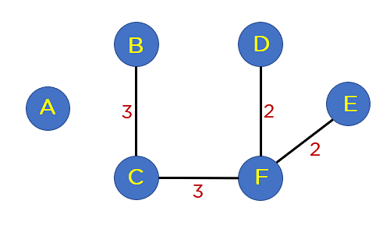

Sıradaki kenar CD. Bu kenar, ağaç yapınızda döngü oluşturur. Bu yüzden, bu kenarı dahil etmiyoruz.
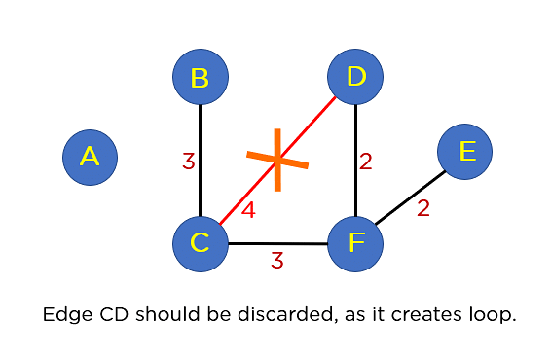
3
B-F’de döngü oluşturur.
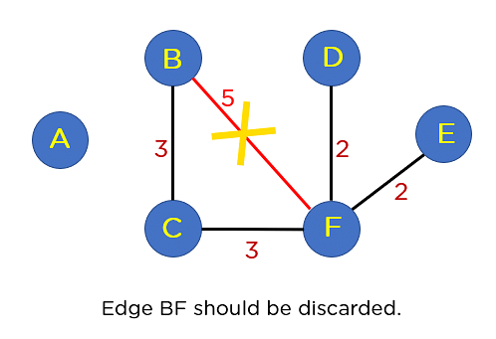
B-D’de döngü oluşturur.
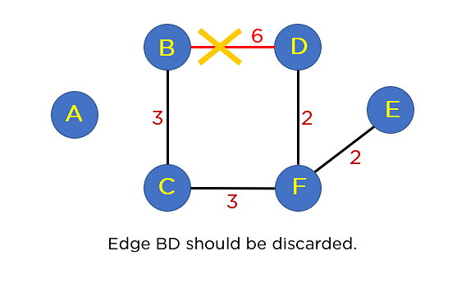
Sıralanmış listenizde bir sonraki AB kenarı var. Bu kenar herhangi bir döngü oluşturmaz, bu nedenle MST yapısına eklemeniz gerekmez. Bu düğümü ekleyerek, MST 5 kenar içerecektir, bu nedenle sıralanan listede daha fazla geçiş yapmanız gerekmez. MST en son böyle görünecek.
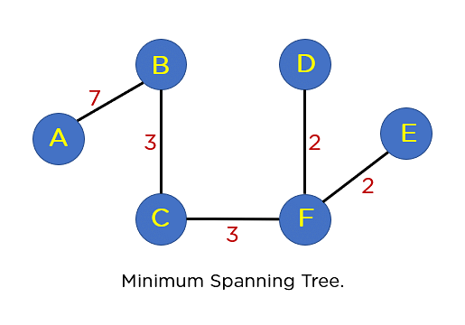
4

Ford-Fulkerson sözde kod ve karmaşıklığı
Maximum Flow Problem

What is Maximum Flow Problem

- Definition: Given a directed network with different capacities on each individual edge, the maximum flow problem asks for the maximum amount of flow that can be sent from a source node(S) to a sink node(T) without exceeding the capacity of any edge.

- Flow in the network should follow the following conditions:

  - For any non-source and non-sink node, the input flow is equal to output flow
  - For any edge(E) in the network, 0 ≤ flow(E) ≤ Capacity(E)
  - Total flow out of the source node is equal to total flow in to the sink node

- There are multiple algorithms exist in solving the maximum flow problem. Today you will see the Ford-Fulkerson algorithm.

Ford-Fulkerson Algorithm

It was developed by L. R. Ford, Jr. and D. R. Fulkerson in 1956.

The Ford-Fulkerson Algorithm computes a maximum flow in a iterative manner by starting with a valid flow, and then making adjustments that fulfill the constraints and increase the flow.

- The complexity of the Ford-Fulkerson algorithm is O(f*E), where f is the maximum flow and E is the number of edges in a network.

There are 2 key elements in the Ford-Fulkerson algorithm:

Residual Network: Residual Network is a graph that has the same vertices as the original network with one or two edges for each edge in the original network. It indicates the additional possible flow through the network. Fer each edge, it calculates as “Additional Flow = Edge’s Capacity – Flow of the Edge”.

So, to create a residual network we will take our original network and will

update the capacity of each edge with the additional flow corresponding to that edge. Then we will also add reverse edges to indicate the amount of flow currently going across the edges of the original network.

  - Augmenting Path: Given a flow network G=(V, E), the augmenting path is a simple path from s to t in the corresponding residual graph of the flow network.

Pseudo Code of Ford-Fulkerson Algorithm

- Input required:
  - Network Graph (G)
  - Source Node (S)
  - Sink Node (T)

- FordFulkerson(Graph G,Node S, Node T):
Initialize flow in all edges to 0
While (There exists and augmenting path(P) between S and T in residual network graph):
Augment flow between S to T along the path P
Update residual network graph
Return flow

Ford-Fulkerson örnek
Example of Ford-Fulkerson Algorithm on Maximum Flow Problem

- Step 1- Set the flow of every edge to 0

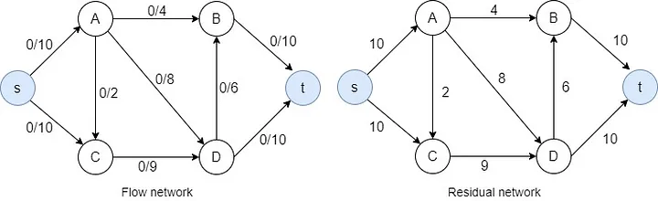

- Step 2- Find an augmenting path in the residual network. ( s→A→D→t)

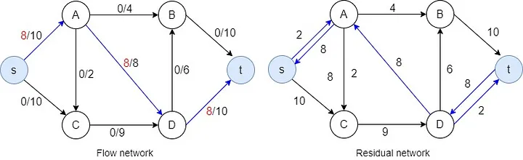

- Step 3- Selecting another augmenting path. (s→C→D→t)

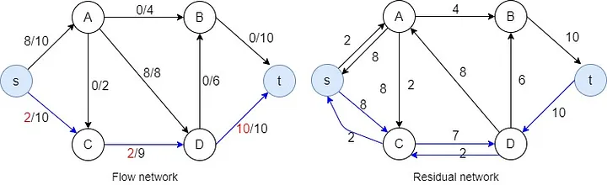

- Step 4- Selecting the augmenting path (s→A→B→t)
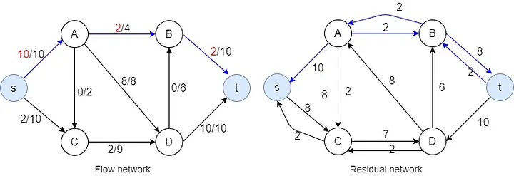

- Step 5- Selecting the augmenting path (s→C→D→B→t)
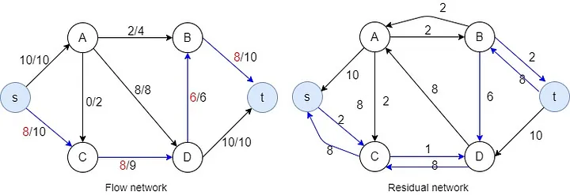

- Step 6- Selecting the augmenting path (s→C→D→A→B→t)

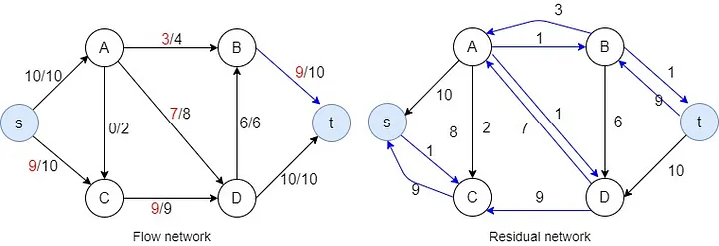

- After 6th step, there is no available capacity in s→A and although there is 1 available capacity in s→C there is no way from there to go to the sink node. Algorithm is now finished and maximum flow calculated as 19 in this case.
Flody Cycle sözde kod ve karmaşıklığı
Floyd Cycle Detection Algorithm | Tortoise and Hare Algorithm
Pseudocode:
İki pointeri(yavaş ve hızlı) listenin başından başlatın ve linked listede gezinmeye başlayın.(slow =head, fast= head)
Yavaş olanı birer birer, (slow= slow->next)
Hızlı olanı ikişer ikişer ilerletin. (fast = fast->next->next)
Eğer iki pointer ortak bir node da buluşuyorsa bir cycle var demektir. (return true)
Eğer hızlı olan pointer listenin sonuna yani null bir değere geliyorsa bir cycle yok demektir. (return false).

Döngünün başlangıcını bulma:
İki pointer buluştuktan sonra yavaş olanı tekrar heade eşitliyoruz.(slow =head)
Hızlı olan buluştukları noktada kalıyor.
Sonra her iki pointer için de birer birer ileriyoruz.
Tekrar buluştukları yer döngünün başlangıcı oluyor. Neden mi?
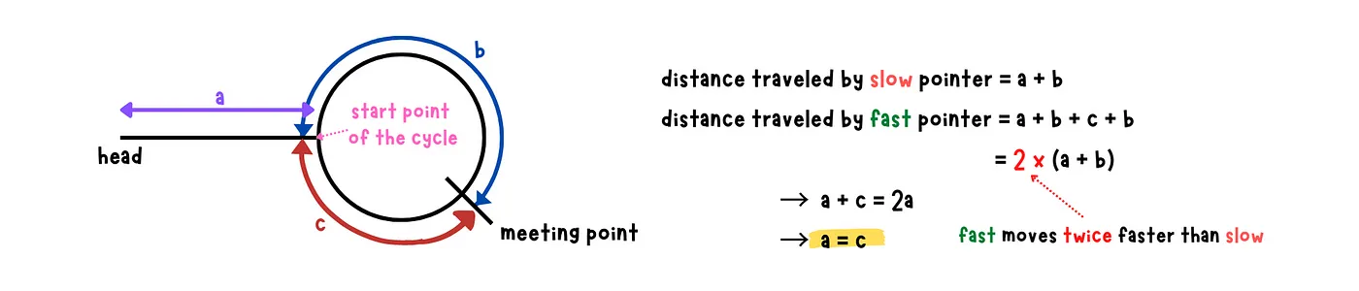

Karmaşıklığı: o(n)
Flood Cycle örnek:
EXAMPLE 1:
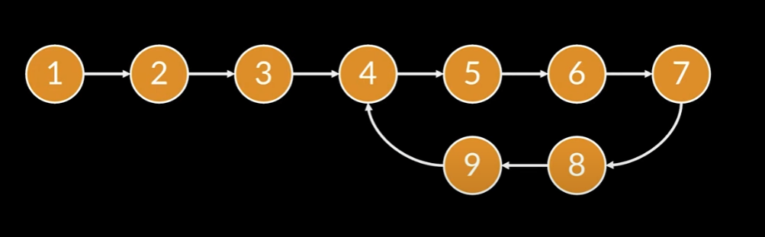
Answer: Döngü var ve döngü başlangıcı 4
Homework ve cevapları:
Dijkstra
Homework:
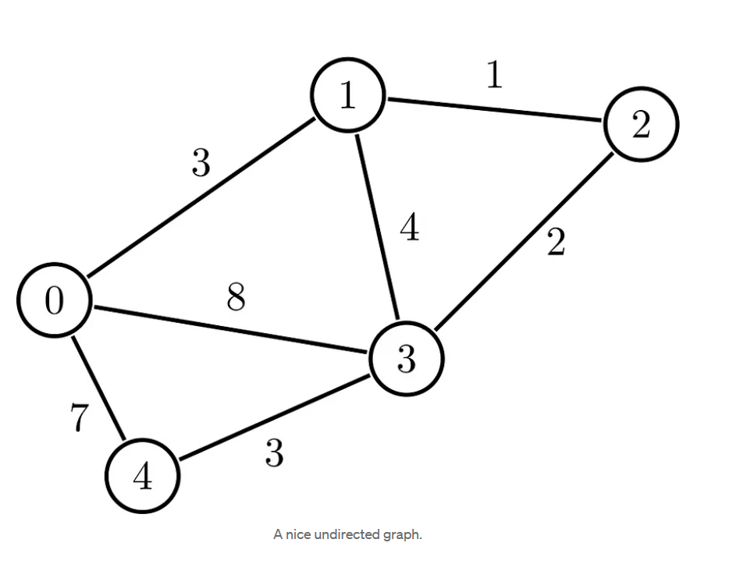
Adım adım çözümü :
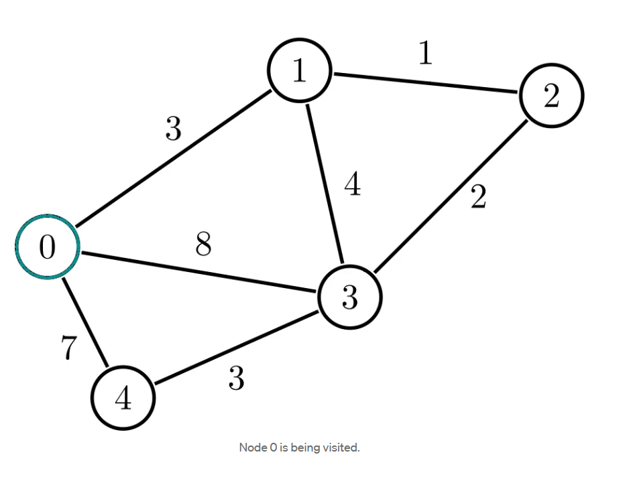
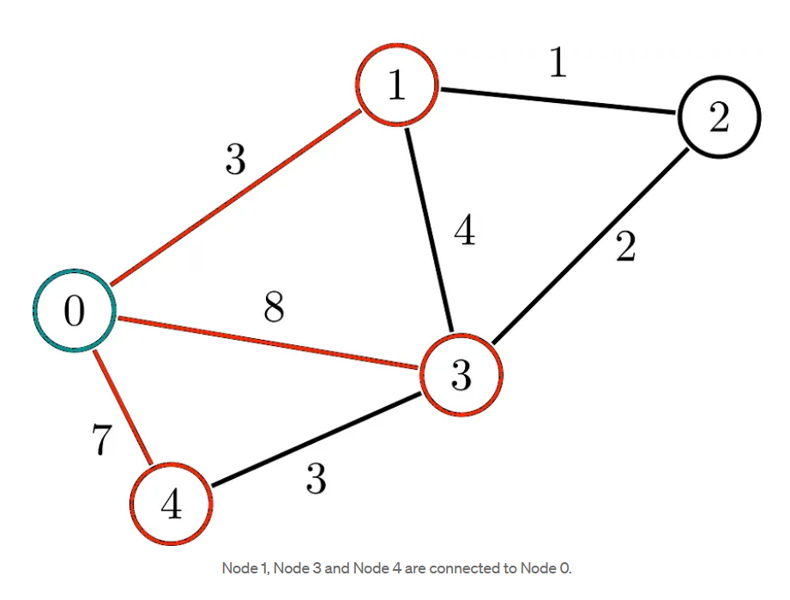
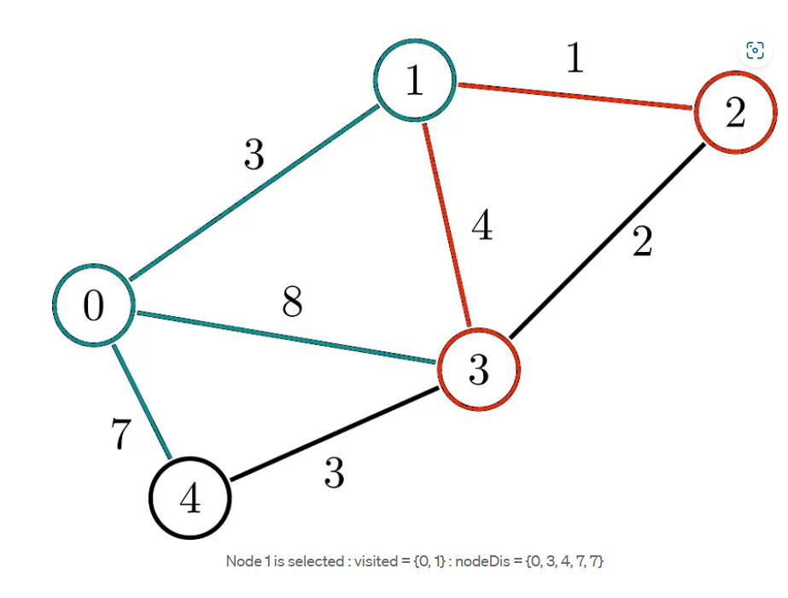
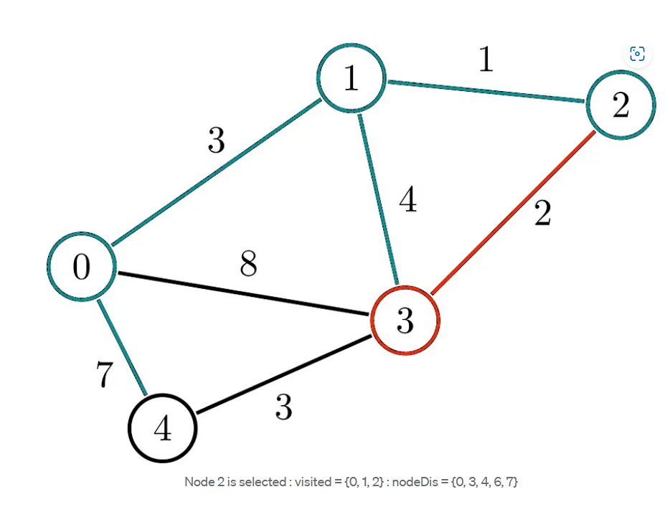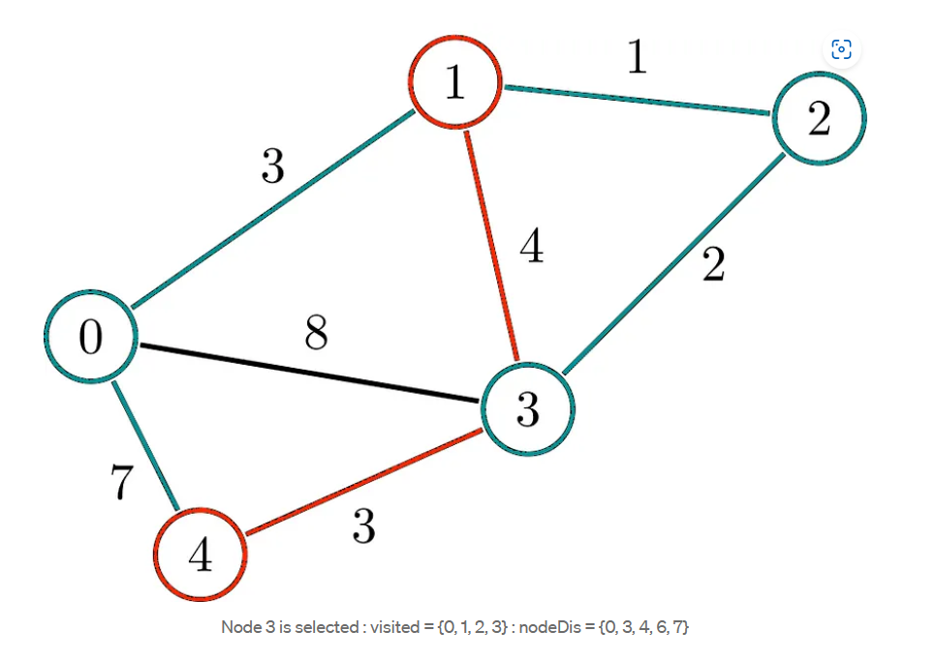
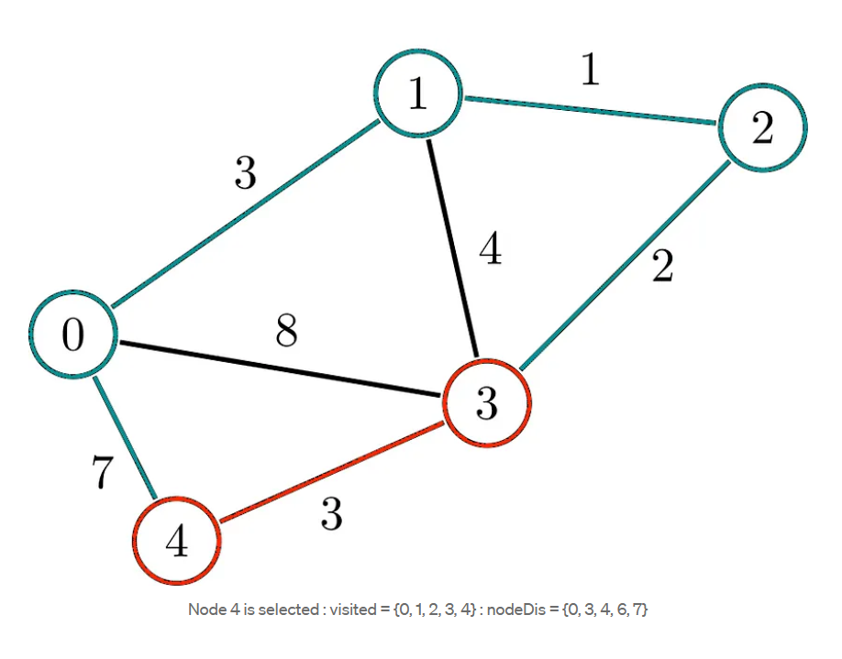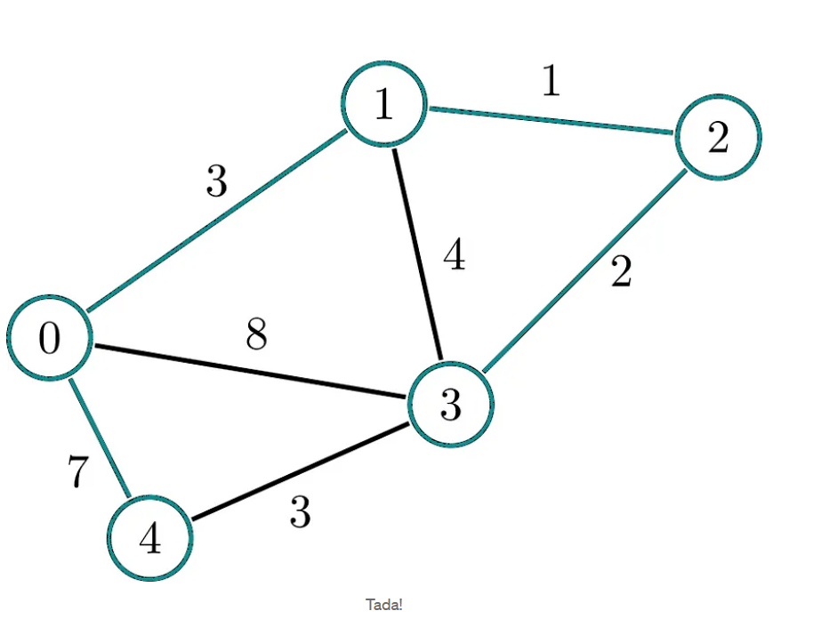
Bellman – Ford
HOMEWORK

A
G
F
E
D
C
B
6
5
5
-2
-1
-2
-1
1
3
3
 | A | B | C | D | E | F | G
1.Iteratıon | 0 | 3 | 3 | 5 | 5 | 4 | 7
2.Iteratıon | 0 | 1 | 3 | 5 | 2 | 4 | 5
3.Iteratıon | 0 | 1 | 3 | 5 | 0 | 4 | 3
4.Iteratıon | 0 | 1 | 3 | 5 | 0 | 4 | 3
5.Iteratıon | 0 | 1 | 3 | 5 | 0 | 4 | 3
6.Iteratıon | 0 | 1 | 3 | 5 | 0 | 4 | 3
Homework for Prim’s algorithm
Consider the following graph as an example for which we need to find the Minimum Spanning Tree (MST).
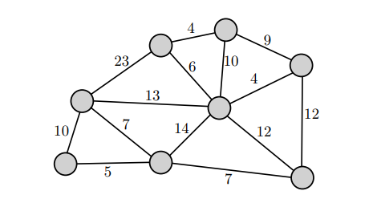

Solution of homework:
Step 1 - Start by adding an arbitrary vertex to Vnew .
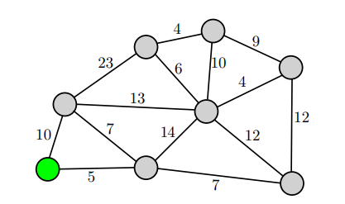
Step 1.1 - we have to find all the edges that connect the tree with the new vertices and mark the edges with blue paint.
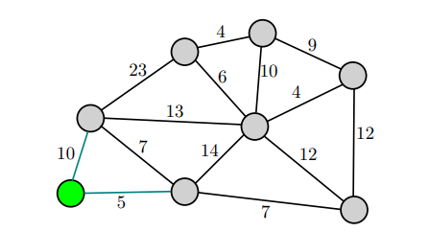

Step 2 - From the edges found, select the minimum edge and mark the vertex with green paint to the tree.
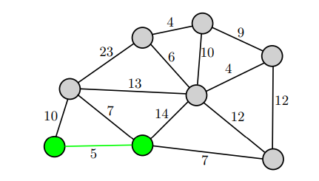

Step 2.1 - we have to find all the edges that connect the tree with the new vertices and mark the edges with blue paint.
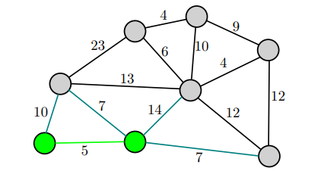

Step 3 - From the edges found, select the minimum edge and mark the vertex with green paint to the tree. If two edges of the same size have the smallest value, it doesn't matter which edge we choose first.(e.g. 7)
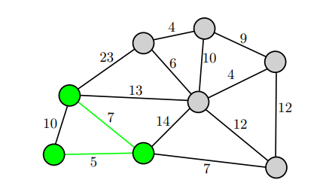

Step 3.1 - we have to find all the edges that connect the tree with the new vertices and mark the edges with blue paint.
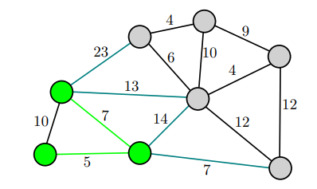

Step 4 - From the edges found, select the minimum edge and mark the vertex with green paint to the tree.
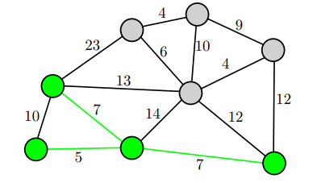

Step 4.1 - we have to find all the edges that connect the tree with the new vertices and mark the edges with blue paint.
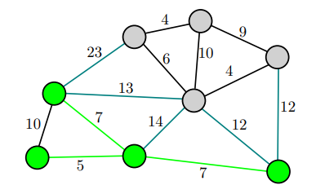

Step 5 - From the edges found, select the minimum edge and mark the vertex with green paint to the tree. If two edges of the same size have the smallest value, it doesn't matter which edge we choose first.(e.g. 12)
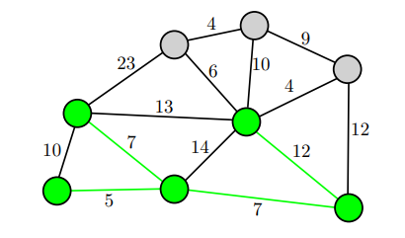

Step 5.1 - we have to find all the edges that connect the tree with the new vertices and mark the edges with blue paint.
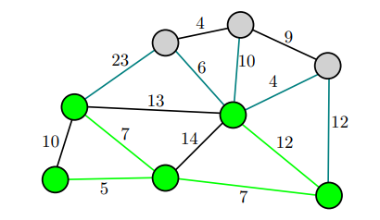

Step 6 - From the edges found, select the minimum edge and mark the vertex with green paint to the tree.
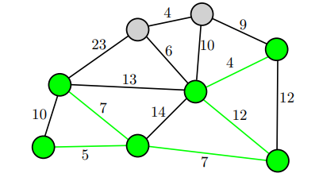

Step 6.1 - we have to find all the edges that connect the tree with the new vertices and mark the edges with blue paint.
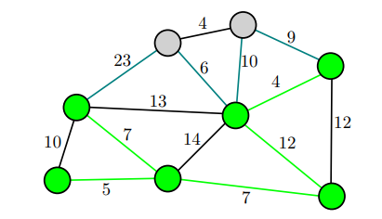

Step 7 - From the edges found, select the minimum edge and mark the vertex with green paint to the tree.
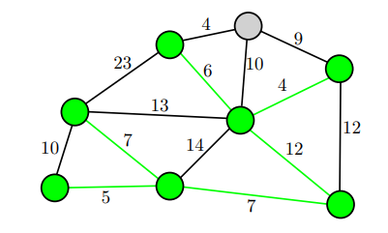

Step 7.1 - we have to find all the edges that connect the tree with the new vertices and mark the edges with blue paint.
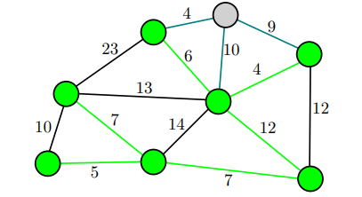

Step 8 - From the edges found, select the minimum edge and mark the vertex with green paint to the tree.
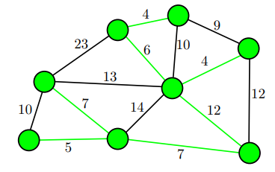

Final Step - Minimum Spanning Tree (MST)

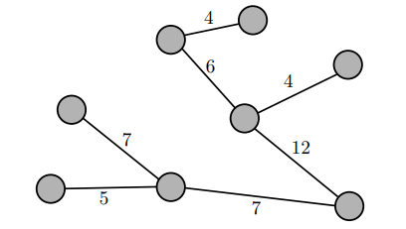

The final structure of the MST is as follows and the weight of the edges of the MST is
(5 + 7 + 7 + 12 + 4 + 6 + 4) = 45

Homework:
Kruskal Algoritmasını kullanarak MST’yi bulunuz.

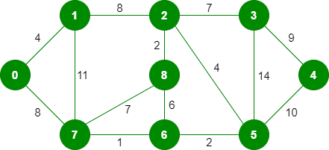

Cevap:

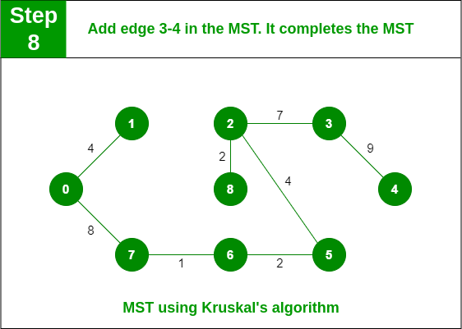

Ford-Fulkerson

Homework:

A company has a factory located in Detroit, USA, producing electric golf carts. The carts will be exported to Asian countries, and are therefore stored in a warehouse in San Francisco. All carts are shipped from the company to San Francisco by train. The train company operates trains daily on the national rail network. The carts are packed in train compartments, called bogeys. There is a limit on how many compartments can be shipped across each link of the train network daily. The network below shows the carrying capacity. What is the maximum number of bogeys that can be shipped out of Detroit each day?

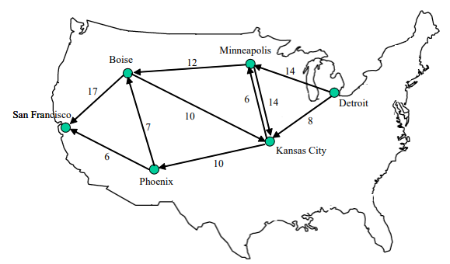

Answer of the Homework : 22
Cycle Detection
EXAMPLE 2:
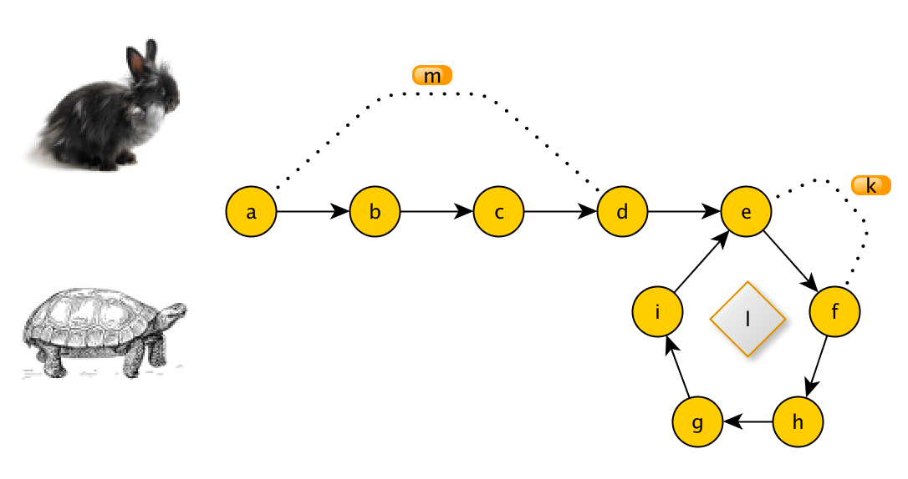
Answer: Döngü var ve döngü başlangıcı e
Kaynaklar:
Kaynaklar: Dijkstra’s Algorithm in an Undirected Graph | by Tom Donovan | The Startup | Medium
Thomas H. Cormen Charles E. Leiserson Ronald L. Rivest Clifford Stein - Introduction to Algorithms
Dijkstra Algorithm: Short terms and Pseudocode (gitta.info)
References
https://www.geeksforgeeks.org/prims-minimum-spanning-tree-mst-greedy-algo-5/
https://www.freecodecamp.org/news/greedy-algorithms/
https://user.it.uu.se/~filma606/ImageProcessingUsingGraphs/LectureNotes/Lecture3.pdf
https://medium.com/cracking-the-coding-interview-in-ruby-python-and/prims-algorithm-explained-with-examples-in-ruby-javascript-and-python-mastering-algorithms-cedc31f1d9c2
https://www.gatevidyalay.com/prims-algorithm-prim-algorithm-example/
https://www.javatpoint.com/prim-algorithm
Referanslar:
https://www.geeksforgeeks.org/kruskals-minimum-spanning-tree-algorithm-greedy-algo-2/
https://www.javatpoint.com/kruskal-algorithm
https://www.e3s-conferences.org/articles/e3sconf/pdf/2021/73/e3sconf_iccsre21_01062.pdf
https://en.wikipedia.org/wiki/Minimum_spanning_tree#:~:text=1.0979027-,Applications,for%2C%20as%20mentioned%20above).
https://www.simplilearn.com/tutorials/data-structure-tutorial/kruskal-algorithm
https://bilgisayarkavramlari.com/2007/12/24/kruskal-asgari-tarama-agaci-algoritmasi/
https://www.hackerearth.com/blog/developers/kruskals-minimum-spanning-tree-algorithm-example/
https://www.sanfoundry.com/kruskals-algorithm-multiple-choice-questions-answers-mcqs/#:~:text=4.,time%20complexity%20of%20Kruskal's%20algorithm%3F&text=Explanation%3A%20Kruskal's%20algorithm%20involves%20sorting,is%20the%20number%20of%20vertices.
REFERENCES
1)https://www.geeksforgeeks.org/bellman-ford-algorithm-dp-23/
2) https://www.youtube.com/watch?v=RD1NTwFUaQo&t=6s
Resources:
https://yuminlee2.medium.com/floyds-cycle-detection-algorithm-b27ed50c607f
https://www.youtube.com/watch?v=S5TcPmTl6ww

https://www.geeksforgeeks.org/floyds-cycle-finding-algorithm/
Resources:

Hackerearth.com

https://www.hackerearth.com/practice/algorithms/graphs/maximum-flow/tutorial/#:~:text=It%20is%20defined%20as%20the,Fulkerson%20algorithm%20and%20Dinic's%20Algorithm.

Stanford University

https://web.stanford.edu/class/archive/cs/cs161/cs161.1168/lecture16.pdf

Medium.com

https://medium.com/@jithmisha/solving-the-maximum-flow-problem-with-ford-fulkerson-method-3fccc2883dc7

Hong Kong University

https://ieda.ust.hk/dfaculty/ajay/courses/ieem101/lecs/graphs/graph-maxflow.pdf

